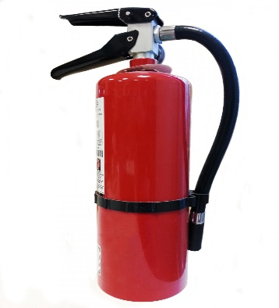
FIRE EXTINGUISHER SALE

The Stephenson County Farm Bureau is offering our voting members an opportunity to order fire extinguishers at a discounted rate. We will accept preorders through August 5th. We will then place our group order and notify those who ordered when their order is ready to pick up at the Farm Bureau or a location near them. Our estimated pick up time is the week of August 16.

Please complete the form below and return it to the Farm Bureau office with your payment. All orders must be received with payment by 4:30 p.m. on August 5. Phone orders with credit card payment will be accepted by calling (815) 232-3186.

xxxxxxxxxxxxxxxxxxxxxxxxxxxxxxxxxxxxxxxxxxxxxxxxxxxxxxxxxxxxxxxxxxxxxxxxxxxxxxxxxxx

Fire Extinguisher Order Form

Name: ________________________________________________________________

Phone: _________________________________________________________________
E-mail: _________________________________________________________________
______ 2.5lb extinguishers at $35.00 _____

______ 5lb extinguisher at $60.00 _______

Each extinguisher comes with a bracket

Total Amount Due: $___________

Payment Method

____ Cash
____ Check (#__________) (Please make payable to Stephenson County Farm Bureau)
____ Credit Card ________________-_______________-________________-________________
Expiration: ______________Name on card: ____________________________________________

MAIL ORDER FORMS TO:
210 W. SPRING STREET
FREEPORT, IL 61032

